P1. Write a C program to print all natural numbers from 1 to n. – using while loop

#include <stdio.h>

void main() {

    int num;

    printf("SHIV ARORA\n");

    printf("Enter a number: ");

    scanf("%d", &num);

    int i=1;

    while(i <= num){

        printf("%d  ", i);

        i++;

    }printf("\n");

}

OUTPUT:

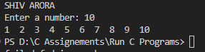

P2. Write a C program to print all natural numbers in reverse (from n to 1). – using while loop

#include <stdio.h>

void main() {

    int num;

    printf("SHIV ARORA\n");

    printf("Enter a number: ");

    scanf("%d", &num);

    int i=num;

    while(i >= 1){

        printf("%d  ", i);

        i--;

    }printf("\n");

}

OUTPUT:

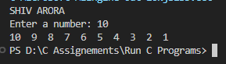

P3. Write a C program to print all alphabets from a to z. – using while loop

#include <stdio.h>

void main() {

    char c = 'a';

    printf("SHIV ARORA\n");

    char i=c;

    while(i <= 'z'){

        printf("%c  ", i);

        i++;

    }printf("\n");

}

OUTPUT:

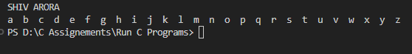

P4. Write a C program to print all even numbers between 1 to 100. – using while loop

#include <stdio.h>

void main() {

    int i = 1;

    printf("SHIV ARORA\n");

    while(i <= 100){

        if(i % 2 == 0)

            printf("%d  ", i);

        i++;

    }printf("\n");

}

OUTPUT:



P5. Write a C program to print all odd number between 1 to 100.

#include <stdio.h>

void main() {

    int i = 1;

    printf("SHIV ARORA\n");

    while(i <= 100){

        if(i % 2 != 0)

            printf("%d  ", i);

        i++;

    }printf("\n");

}

OUTPUT:



P6. Write a C program to find sum of all natural numbers between 1 to n

#include <stdio.h>

void main() {

    int n;

    printf("SHIV ARORA\n");

    printf("Enter a number ");

    scanf("%d", &n);

    int sum = 0;

    int i = 1;

    while(i <= n){

        sum += i;

        i++;

    }printf("SUM  = %d\n", sum);

}

OUTPUT:

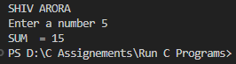

P7. Write a C program to find sum of all even numbers between 1 to n.

#include <stdio.h>

void main() {

    int n;

    printf("SHIV ARORA\n");

    printf("Enter a number ");

    scanf("%d", &n);

    int sum = 0;

    int i = 1;

    while(i <= n){

        if (i% 2 == 0)

            sum += i;

        i++;

    }printf("SUM  = %d\n", sum);

}

OUTPUT:

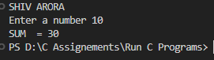

P8. Write a C program to find sum of all odd numbers between 1 to n.

#include <stdio.h>

void main() {

    int n;

    printf("SHIV ARORA\n");

    printf("Enter a number ");

    scanf("%d", &n);

    int sum = 0;

    int i = 1;

    while(i <= n){

        if (i% 2 != 0)

            sum += i;

        i++;

    }printf("SUM  = %d\n", sum);

}

OUTPUT:

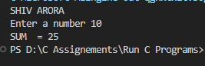

P9. Write a C program to print multiplication table of any number.

#include <stdio.h>

void main() {

    int n;

    printf("SHIV ARORA\n");

    printf("Enter a number ");

    scanf("%d", &n);

    int i = 1;

    while(i <= 10){

        printf("%d * %d = %d\n", n, i, n*i);

        i++;

    }printf("\n");

}

OUTPUT:

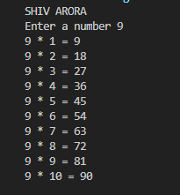

P10. Write a C program to count number of digits in a number.

#include <stdio.h>

void main() {

    int n;

    printf("SHIV ARORA\n");

    printf("Enter a number ");

    scanf("%d", &n);

    int i = 0;

    while(n != 0){

        n /= 10;

        i++;

    }printf("%d\n", i);

}

OUTPUT:



P11. Write a C program to find first and last digit of a number

#include <stdio.h>

void main() {

    int n, ld;

    printf("SHIV ARORA\n");

    printf("Enter a number ");

    scanf("%d", &n);

    ld = n% 10;

    printf("%d\n", ld);

}

OUTPUT:

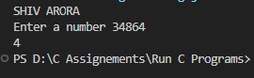

P12. Write a C program to swap first and last digits of a number.

#include <stdio.h>

void main() {

    int n, ld, fd;

    printf("SHIV ARORA\n");

    printf("Enter a number ");

    scanf("%d", &n);

    ld = n% 10;

     while (n >= 10) {

        n /= 10;

    }

    fd = n;

    printf("%d\n", ld+fd);

}

OUTPUT:

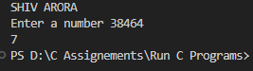

P13. Write a C program to swap first and last digits of a number.

#include <stdio.h>

void main() {

    int n, fd, ld, swap, digits = 0;

    printf("SHIV ARORA\n");

    printf("Enter a number: ");

    scanf("%d", &n);

    int temp = n;

    ld = n % 10;

    while (n >= 10) {

        n /= 10;

        digits++;

    }

    fd = n;

    swap = ld;

    for (int i = 0; i < digits - 1; i++) {

        temp = temp / 10;

        swap = swap * 10 + (temp % 10);

    }

    swap = swap * 10 + fd;

    printf("Swapperd Number %d\n", swap);

}

OUTPUT:

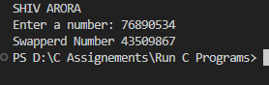

P14. Write a C program to calculate sum of digits of a number

#include <stdio.h>

void main() {

    int n, sum = 0;

    printf("SHIV ARORA\n");

    printf("Enter a number: ");

    scanf("%d", &n);

    while (n > 0) {

        sum += n % 10;

        n /= 10;

    }

    printf("Sum = %d\n", sum);

}

OUTPUT:

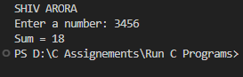

P15. Write a C program to calculate product of digits of a number.

#include <stdio.h>

void main() {

    int n, sum = 1;

    printf("SHIV ARORA\n");

    printf("Enter a number: ");

    scanf("%d", &n);

    while (n > 0) {

        sum *= n % 10;

        n /= 10;

    }

    printf("Sum = %d\n", sum);

}

OUTPUT:

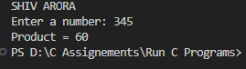

P16. Write a C program to enter a number and print its reverse.

#include <stdio.h>

void main() {

    int n, rev = 0;

    printf("SHIV ARORA\n");

    printf("Enter a number: ");

    scanf("%d", &n);

    while (n != 0) {

        rev = rev*10 + n%10;

        n /= 10;

    }

    printf("Reverse = %d\n", rev);

}

OUTPUT:

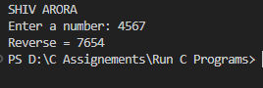

P17. Write a C program to check whether a number is palindrome or not

#include <stdio.h>

void main() {

    int n, rev =0;

    printf("SHIV ARORA\n");

    printf("Enter a number: ");

    scanf("%d", &n);

    int org = n;

    while (n != 0) {

        rev = rev*10 + n%10;

        n /= 10;

    }

    if(org == rev)

    printf("Palindrome");

    else

    printf("Not Palindrome");

}

OUTPUT:

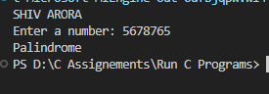

P18. Write a C program to find frequency of each digit in a given integer.

#include <stdio.h>

void main() {

    int n, digit = 0;

    printf("SHIV ARORA\n");

    printf("Enter a number: ");

    scanf("%d", &n);

    int freq[10] = {0};

    while (n != 0) {

        digit = n% 10;

        freq[digit]++;

        n /= 10;

    }

    printf("ALL Digit Frequencies:\n");

    for (digit = 0; digit < 10; digit++) {

        if(freq[digit] == 0 ) continue;

        else printf(" %d ->  (%d)\n", digit, freq[digit]);

    }

}

OUTPUT:

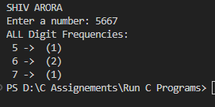

P20. Write a C program to print all ASCII character with their values.

#include <stdio.h>

void main() {

    printf("SHIV ARORA");

    printf("ASCII Characters and their Values are :\n");

    for (int i = 0; i < 128; i++) {

        printf("Char: %c  |  Value: %d\n", i, i);

    }

}

OUPUT:

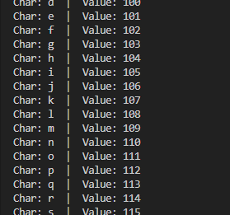

P21. Write a C program to find power of a number using for loop

#include <stdio.h>

void main() {

    int exp, n;

    printf("SHIV ARORA\n");

    printf("Enter the number then the exponent ");

    scanf("%d %d", &n, &exp);

    int ans = 1;

    for (int i = 0; i < exp; i++) {

        ans *= n;

    }

    printf("%d", ans);

}

OUTPUT:

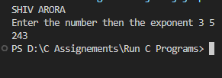

P22. Write a C program to find all factors of a number.

#include <stdio.h>

void main() {

    int  n;

    printf("SHIV ARORA\n");

    printf("Enter the number ");

    scanf("%d", &n);

    for (int i = 1; i <= n; i++) {

        if (n % i == 0)  printf("%d ", i);

    }

}

OUTPUT:

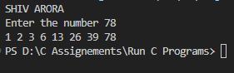

P23. Write a C program to calculate factorial of a number.

#include <stdio.h>

void main() {

    int  n;

    printf("SHIV ARORA\n");

    printf("Enter the factorial ");

    scanf("%d", &n);

    int ans = 1;

    for (int i = 0; i < n; i++) {

        ans *= n-i;

    }

    printf("%d", ans);

}

OUTPUT:

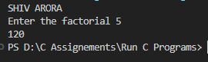

P24. Write a C program to find HCF (GCD) of two numbers.

#include <stdio.h>

void main() {

    int  n1, n2 , hcf;

    printf("SHIV ARORA\n");

    printf("Enter two numbers ");

    scanf("%d %d", &n1, &n2);

    while (n2 != 0) {

        hcf = n2;

        n2 = n1 % n2;

        n1 = hcf;

    }

    printf("HCF = %d", hcf);

}

OUTPUT:

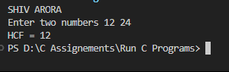

P25. Write a C program to find LCM of two numbers.

#include <stdio.h>

void main() {

    int  n1, n2 , hcf, lcm;

    printf("SHIV ARORA\n");

    printf("Enter two numbers ");

    scanf("%d %d", &n1, &n2);

    int t1= n1, t2 = n2;

    while (n2 != 0) {

        hcf = n2;

        n2 = n1 % n2;

        n1 = hcf;

    }

    lcm = (t1 * t2) / hcf;

    printf("LCM = %d", lcm);

}

OUTPUT:

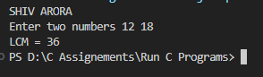

P26. Write a C program to check whether a number is Prime number or not.

#include <stdio.h>

void main() {

    int  n , prime_check;

    printf("SHIV ARORA\n");

    printf("Enter a numbers ");

    scanf("%d", &n);

     if (n < 2) {

        prime_check = 0;

    } else {

        for (int i = 2; i * i <= n; i++) {

            if (n % i == 0) {

                prime_check = 0;

                break;

            }

        }

    }

    if (prime_check) {

        printf("prime number.\n");

    } else {

        printf("not a prime number.\n");

    }

}

OUTPUT:

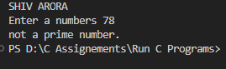

P27. Write a C program to print all Prime numbers between 1 to n.

#include <stdio.h>

void main() {

    int  n;

    printf("SHIV ARORA\n");

    printf("Enter a numbers ");

    scanf("%d", &n);

    for (int i = 2; i <= n; i++) {

        int prime_check = 1;

        for (int j = 2; j * j <= i; j++) {

            if (i % j == 0) {

                prime_check = 0;

                break;

            }

        }

        if (prime_check) {

            printf("%d ", i);

        }

    }

}

OUTPUT:

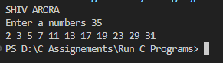

P28. Write a C program to find sum of all prime numbers between 1 to n

#include <stdio.h>

void main() {

    int  n, sum=0;

    printf("SHIV ARORA\n");

    printf("Enter a numbers ");

    scanf("%d", &n);

    for (int i = 2; i <= n; i++) {

        int prime_check = 1;

        for (int j = 2; j * j <= i; j++) {

            if (i % j == 0) {

                prime_check = 0;

                break;

            }

        }

        if (prime_check) {

            sum += i;

        }

    }

    printf("%d", sum);

}

OUTPUT:

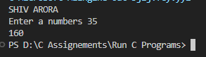

P29. Write a C program to find all prime factors of a number.

#include <stdio.h>

int isPrime(int num) {

    if (num < 2) return 0;

    for (int i = 2; i * i <= num; i++) {

        if (num % i == 0) return 0;

    }

    return 1;

}

void main() {

    int  n;

    printf("SHIV ARORA\n");

    printf("Enter a numbers ");

    scanf("%d", &n);

    for (int i = 2; i <= n; i++) {

        while (n % i == 0) {

            if (isPrime(i)) {

                printf("%d ", i);

            }

            n /= i;

        }

    }

}

OUTPUT:

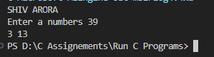

P30. Write a C program to check whether a number is Armstrong number or not.

#include <stdio.h>

void main() {

    int  n, remainder, ans =0;

    printf("SHIV ARORA\n");

    printf("Enter a numbers ");

    scanf("%d", &n);

    int org = n;

    while (org != 0) {

        remainder = org % 10;

        ans += remainder * remainder * remainder;

        org /= 10;

    }

    if (ans == n) {

        printf("Armstrong number.\n");

    } else {

        printf("not an Armstrong number.\n");

    }

}

OUTPUT:

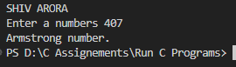

P31. Write a C program to print all Armstrong numbers between 1 to n

#include <stdio.h>

#include<math.h>

void main() {

    int  n, remainder;

    printf("SHIV ARORA\n");

    printf("Enter a numbers ");

    scanf("%d", &n);

    for (int num = 1; num <= n; num++) {

        int org = num, remainder, ans = 0, digit = 0;

        while (org != 0) {

            org /= 10;

            digit++;

        }

        org = num;

        while (org != 0) {

            remainder = org % 10;

            ans += pow(remainder, digit);

            org /= 10;

        }

        if (ans == num) {

            printf("%d ", num);

        }

    }

}

OUTPUT:

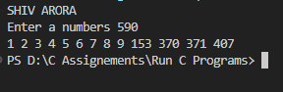

P32. Write a C program to check whether a number is Perfect number or not.

#include <stdio.h>

void main() {

    int  n, sum;

    printf("SHIV ARORA\n");

    printf("Enter a numbers ");

    scanf("%d", &n);

   for (int i = 1; i <= n / 2; i++) {

        if (n % i == 0) sum += i;

    }

    if (sum == n && n != 0)  printf("Perfect number.\n");

     else  printf("not a Perfect number.\n");

}

OUTPUT:

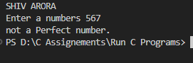

P33. Write a C program to print all Perfect numbers between 1 to n.

#include <stdio.h>

void main() {

    int  n;

    printf("SHIV ARORA\n");

    printf("Enter a numbers ");

    scanf("%d", &n);

   for (int num = 1; num <= n; num++) {

        int sum = 0;

        for (int i = 1; i <= num / 2; i++) {

            if (num % i == 0) sum += i;

        }

        if (sum == num) printf("%d ", num);

    }

}

OUTPUT:

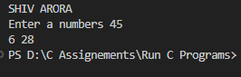

P34. Write a C program to check whether a number is Strong number or not.

#include <stdio.h>

int factorial(int num) {

    int fact = 1;

    for (int i = 1; i <= num; i++) {

        fact *= i;

    }

    return fact;

}

void main() {

    int  n, sum=0;

    printf("SHIV ARORA\n");

    printf("Enter a numbers ");

    scanf("%d", &n);

    int org = n;

    while (n != 0) {

        int digit = n % 10;

        sum += factorial(digit);

        n /= 10;

    }

    if (sum == org) {

        printf("Strong number.\n");

    } else {

        printf("not a Strong number.\n");

    }

}

OUTPUT:

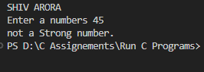

P35. Write a C program to print all Strong numbers between 1 to n.

#include <stdio.h>

int factorial(int num) {

    int fact = 1;

    for (int i = 1; i <= num; i++) {

        fact *= i;

    }

    return fact;

}

void main() {

    int  n;

    printf("SHIV ARORA\n");

    printf("Enter a numbers ");

    scanf("%d", &n);

    for (int i = 1; i<= n; i++) {

        int sum = 0, org = i;

        while (org != 0) {

            int digit = org % 10;

            sum += factorial(digit);

            org /= 10;

        }

        if (sum == i) printf("%d ", i);

    }

}

OUTPUT:

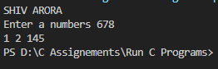

P36. Write a C program to print Fibonacci series up to n terms.

#include <stdio.h>

int fib(int n) {

    if (n <= 0) {

        return 0;

    } else if (n == 1) {

        return 1;

    } else {

        return fib(n - 1) + fib(n - 2);

    }

}

void main() {

    int  n;

    printf("SHIV ARORA\n");

    printf("Enter a numbers ");

    scanf("%d", &n);

    for (int i = 0; i < n; i++) {

        printf("%d ", fib(i));

    }

}

OUTPUT:

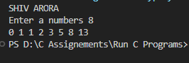

P37. Write a C program to find one’s complement of a binary number.

#include <stdio.h>

#include <string.h>

void main() {

    printf("SHIV ARORA\n");

    char b[100];

    printf("Enter a binary number: ");

    scanf("%s", b);

    for (int i = 0; i < strlen(b); i++) {

        if (b[i] == '0') printf("1");

        else printf("0");

        }

}

OUTPUT:

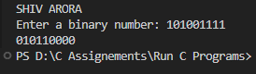

P38. Write a C program to find two’s complement of a binary number.

#include <stdio.h>

#include <string.h>

void main() {

    printf("SHIV ARORA\n");

    char b[100];

    int carry = 1;

    printf("Enter a binary number: ");

    scanf("%s", b);

    for (int i = strlen(b) - 1; i >= 0; i--) {

        if (b[i] == '0' && carry == 1) {

            b[i] = '1';

            carry = 0;

            break;

        } else if (b[i] == '1' && carry == 1) b[i] = '0';

    }

    if (carry == 1) printf("Two's complement cannot be represented.\n");

    else printf("%s\n", b);

}

OUTPUT:

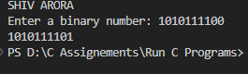

P39. Write a C program to convert Binary to Octal number system.

#include <stdio.h>

#include <string.h>

void main() {

    printf("SHIV ARORA\n");

    char b[100];

    int decimal = 0, octal = 0, remain;

    printf("Enter a binary number: ");

    scanf("%s", b);

    for (int i = 0; b[i] != '\0'; i++) {

        decimal = decimal * 2 + (b[i] - '0');

    }

    int a = 1;

    while (decimal != 0) {

        remain = decimal % 8;

        octal += remain * a;

        decimal /= 8;

        a *= 10;

    }

    printf("%d\n", octal);

}

OUTPUT:

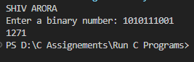

P40. Write a C program to convert Binary to Decimal number system.

#include <stdio.h>

#include <string.h>

void main() {

    printf("SHIV ARORA\n");

    char b[100];

    int decimal = 0;

    printf("Enter a binary number: ");

    scanf("%s", b);

    for (int i = 0; b[i] != '\0'; i++) {

        decimal = decimal * 2 + (b[i] - '0');

    }

    printf("%d\n", decimal);

}

OUTPUT:

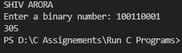

P41. Write a C program to convert Binary to Hexadecimal number system.

#include <stdio.h>

#include <string.h>

void main() {

    printf("SHIV ARORA\n");

    char b[100];

    int decimal = 0;

    printf("Enter a binary number: ");

    scanf("%s", b);

    for (int i = 0; b[i] != '\0'; i++) {

        decimal = decimal * 2 + (b[i] - '0');

    }

    printf("%X\n", decimal);

}

OUTPUT:

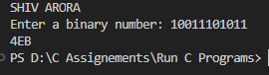

P42. Write a C program to convert Octal to Binary number system.

#include <stdio.h>

void main() {

    printf("SHIV ARORA\n");

    int oct, decimal = 0, b = 0, i = 1;

    printf("Enter an octal number: ");

    scanf("%d", &oct);

    while (oct != 0) {

        decimal += (oct % 10) * i;

        oct /= 10;

        i *= 8;

    }

    i = 1;

    while (decimal != 0) {

        b += (decimal % 2) * i;

        decimal /= 2;

        i *= 10;

    }

    printf("%d\n", b);

}

OUTPUT:

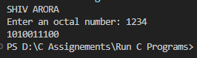

P43. Write a C program to convert Octal to Decimal number system.

#include <stdio.h>

void main() {

    printf("SHIV ARORA\n");

    int oct, decimal = 0, i = 0;

    printf("Enter an octal number: ");

    scanf("%d", &oct);

    while (oct != 0) {

        decimal += (oct % 10) * (1 << (3 * i));

        oct /= 10;

        i++;

    }

    printf("%d\n", decimal);

}

OUTPUT:

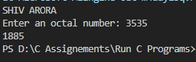

P44. Write a C program to convert Octal to Hexadecimal number system.

#include <stdio.h>

void main() {

    printf("SHIV ARORA\n");

    int oct, decimal = 0, hex = 0, i = 1;

    printf("Enter an octal number: ");

    scanf("%d", &oct);

    while (oct != 0) {

        decimal += (oct % 10) * i;

        oct /= 10;

        i *= 8;

    }

    i = 1;

    while (decimal != 0) {

        hex += (decimal % 16) * i;

        decimal /= 16;

        i *= 10;

    }

    printf("%d\n", hex);

}

OUTPUT:

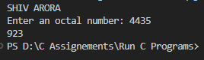

P45. Write a C program to convert Decimal to Binary number system.

#include <stdio.h>

void main() {

    printf("SHIV ARORA\n");

    int decimal, b[32], i = 0;

    printf("Enter a decimal number: ");

    scanf("%d", &decimal);

    while (decimal > 0) {

        b[i++] = decimal % 2;

        decimal /= 2;

    }

    for (i = i - 1; i >= 0; i--) {

        printf("%d", b[i]);

    }

}

OUTPUT:

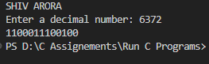

P46. Write a C program to convert Decimal to Octal number system.

#include <stdio.h>

void main() {

    printf("SHIV ARORA\n");

     int decimal, oct = 0, i = 1;

    printf("Enter a decimal number: ");

    scanf("%d", &decimal);

    while (decimal > 0) {

        oct += (decimal % 8) * i;

        decimal /= 8;

        i *= 10;

    }

    printf("%d\n", oct);

}

OUTPUT:

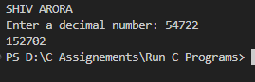

P47. Write a C program to convert Decimal to Hexadecimal number system.

#include <stdio.h>

void main() {

    printf("SHIV ARORA\n");

     int decimal;

    printf("Enter a decimal number: ");

    scanf("%d", &decimal);

    printf("%X\n", decimal);

}

OUTPUT:

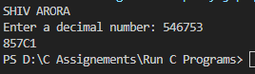

P48. Write a C program to convert Hexadecimal to Binary number system.

#include <stdio.h>

#include<stdlib.h>

void main() {

    printf("SHIV ARORA\n");

    char hex[100];

    int decimal;

    printf("Enter a hexadecimal number: ");

    scanf("%s", hex);

    decimal = strtol(hex, NULL, 16);

    for (int i = sizeof(decimal) * 8 - 1; i >= 0; i--) {

        printf("%d", (decimal >> i) & 1);

    }

}

OUTPUT:

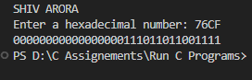

P49. Write a C program to convert Hexadecimal to Octal number system.

#include <stdio.h>

#include<stdlib.h>

void main() {

    printf("SHIV ARORA\n");

    char hex[100];

    long decimal;

    printf("Enter a hexadecimal number: ");

    scanf("%s", hex);

    decimal = strtol(hex, NULL, 16);

    printf("%lo\n", decimal);

}

OUTPUT:

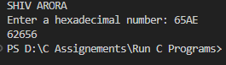

P50. Write a C program to convert Hexadecimal to Decimal number system.

#include <stdio.h>

#include<stdlib.h>

void main() {

    printf("SHIV ARORA\n");

    char hex[100];

    int decimal;

    printf("Enter a hexadecimal number: ");

    scanf("%s", hex);

    decimal = strtol(hex, NULL, 16);

    printf(" %d\n", decimal);

}

OUTPUT:

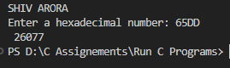

P51. Write a C program to print Pascal triangle up to n rows.

#include <stdio.h>

void main() {

    printf("SHIV ARORA\n");

    int n, coef = 1;

    printf("Enter number of rows: ");

    scanf("%d", &n);

    for (int line = 0; line < n; line++) {

        for (int space = 0; space < n - line - 1; space++)

            printf(" ");

        coef = 1;

        for (int i = 0; i <= line; i++) {

            printf("%d ", coef);

            coef = coef * (line - i) / (i + 1);

        }

        printf("\n");

    }

}

OUTPUT:

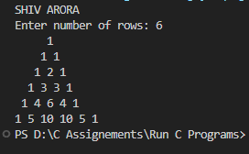

P52. Star pattern programs – Write a C program to print the given star patterns.

#include <stdio.h>

void pyramidPattern(int n) {

    for (int i = 0; i < n; i++) {

        for (int j = 0; j < n - i - 1; j++)

            printf(" ");

        for (int j = 0; j <= i; j++)

            printf("* ");

        printf("\n");

    }

}

void inverseRightTriangle(int n) {

    for (int i = n; i > 0; i--) {

        for (int j = 0; j < i; j++)

            printf("* ");

        printf("\n");

    }

}

void hollowInvertedPyramid(int n) {

    for (int i = n; i > 0; i--) {

        for (int j = 0; j < n - i; j++)

            printf(" ");

        for (int j = 0; j < (2 * i - 1); j++) {

            if (j == 0 || j == (2 * i - 2) || i == n)

                printf("*");

            else

                printf(" ");

        }

        printf("\n");

    }

}

void hollowPyramid(int n) {

    for (int i = 0; i < n; i++) {

        for (int j = 0; j < n - i - 1; j++)

            printf(" ");

        for (int j = 0; j <= i; j++) {

            if (j == 0 || j == i || i == n - 1)

                printf("* ");

            else

                printf("  ");

        }

        printf("\n");

    }

}

void diamondPattern(int n) {

    int i, k, count = n - 1;

    for (k = 1; k <= n; k++) {

        for (i = 1; i <= count; i++)

            printf(" ");

        count--;

        for (i = 1; i <= 2 * k - 1; i++)

            printf("*");

        printf("\n");

    }

    count = 1;

    for (k = 1; k <= n - 1; k++) {

        for (i = 1; i <= count; i++)

            printf(" ");

        count++;

        for (i = 1; i <= 2 * (n - k) - 1; i++)

            printf("*");

        printf("\n");

    }

}

void halfDiamondPattern(int n) {

    for (int i = 0; i <= n; i++) {

        for (int j = 0; j < i; j++)

            printf("* ");

        printf("\n");

    }

    for (int i = n - 1; i >= 0; i--) {

        for (int j = 0; j < i; j++)

            printf("* ");

        printf("\n");

    }

}

void main() {

    printf("SHIV ARORA\n");

    int n;

    printf("Enter number of rows: ");

    scanf("%d", &n);

    printf("Pyramid Pattern:\n");

    pyramidPattern(n);

    printf("Inverse Right Triangle:\n");

    inverseRightTriangle(n);

    printf("Hollow Inverted Pyramid:\n");

    hollowInvertedPyramid(n);

    printf("Hollow Pyramid:\n");

    hollowPyramid(n);

    printf("Diamond Star Pattern:\n");

    diamondPattern(n);

    printf("\nHalf Diamond Pattern:\n");

    halfDiamondPattern(n);

}

OUTPUT:

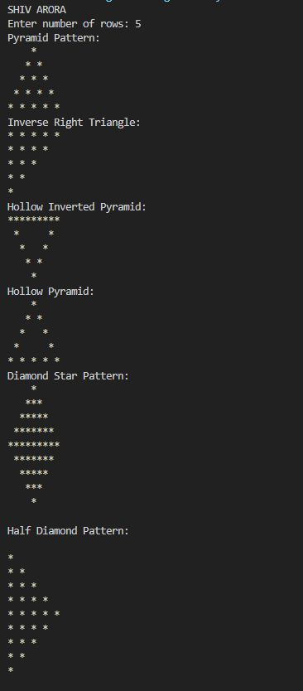

P53. Number pattern programs – Write a C program to print the given number patterns.

#include <stdio.h>

void halfPyramid(int rows) {

     for (int i = 1; i <= rows; ++i)   {

        for (int j = 1; j <= i; ++j)   {

            printf ("%d ", j);

        }

        printf ("\n");

    }

}

void invertedHalfPyramid(int n) {

    for (int i = n; i >= 1; i--) {

        for (int j = 1; j <= i; j++)

            printf("%d ", j);

        printf("\n");

    }

}

void hollowHalfPyramid(int n) {

    for (int i = 1; i <= n; i++) {

        for (int j = 1; j <= i; j++) {

            if (j == 1 || j == i || i == n)

                printf("%d ", j);

            else

                printf("  ");

        }

        printf("\n");

    }

}

void fullPyramid(int rows) {

    for (int i =1; i <= rows; i++) {

        for (int j = 1; j <= rows - i; j++) {

            printf ("  ");

        }

        for (int k = 1; k <= ( 2 * i - 1); k++){

            printf ("%d ",i);

        }

        printf ("\n");

    }

}

void hollowFullPyramid(int n) {

    for (int i = 1; i <= n; i++) {

        for (int j = i; j < n; j++)

            printf(" ");

        for (int j = 1; j <= (2 * i - 1); j++) {

            if (j == 1 || j == (2 * i - 1))

                printf(" %d", i);

            else

                printf(" ");

        }

        printf("\n");

    }

    for (int i = 1; i <= n; i++)

        printf("%d  ", i);

}

void hollowInvertedPyramid(int n) {

   for (int i = 1; i <= n; i++) {

        for (int j = 1; j <= n; j++) {

            if (i == 1) {

                printf("%d ", j);

            } else if (j == i || j == n) {

                printf("%d ", j);

            } else {

                printf("  ");

            }

        }

        printf("\n");

    }

}

int main() {

    printf("SHIV AROR\n");

    int n;

    printf("Enter number of rows: ");

    scanf("%d", &n);

    printf("\nHalf Pyramid:\n");

    halfPyramid(n);

    printf("\nInverted Half Pyramid:\n");

    invertedHalfPyramid(n);

    printf("\nHollow Half Pyramid:\n");

    hollowHalfPyramid(n);

    printf("\nFull Pyramid:\n");

    fullPyramid(n);

    printf("\nHollow Full Pyramid:\n");

    hollowFullPyramid(n);

    printf("\nHollow Inverted Pyramid:\n");

    hollowInvertedPyramid(n);

}

OUTPUT:

